**Figure 1**. Distribution of *Quercus pyrenaica* forests in the Iberian Peninsula (a) and in Sierra Nevada mountain range (b). Different colours indicate oak population cluster’s identified in Sierra Nevada (Pérez-Luque et al. 2015). For each population, a grid with the MODIS pixels is shown (see material and methods). Detailed location of the dendroecological sampling sites: northern (San Juan, SJ) (c), and southern ones (Cáñar: CA-Low and CA-High) (d). Colour orthophotography of 2009 from Regional Ministry of the Environment (IECA 2009).

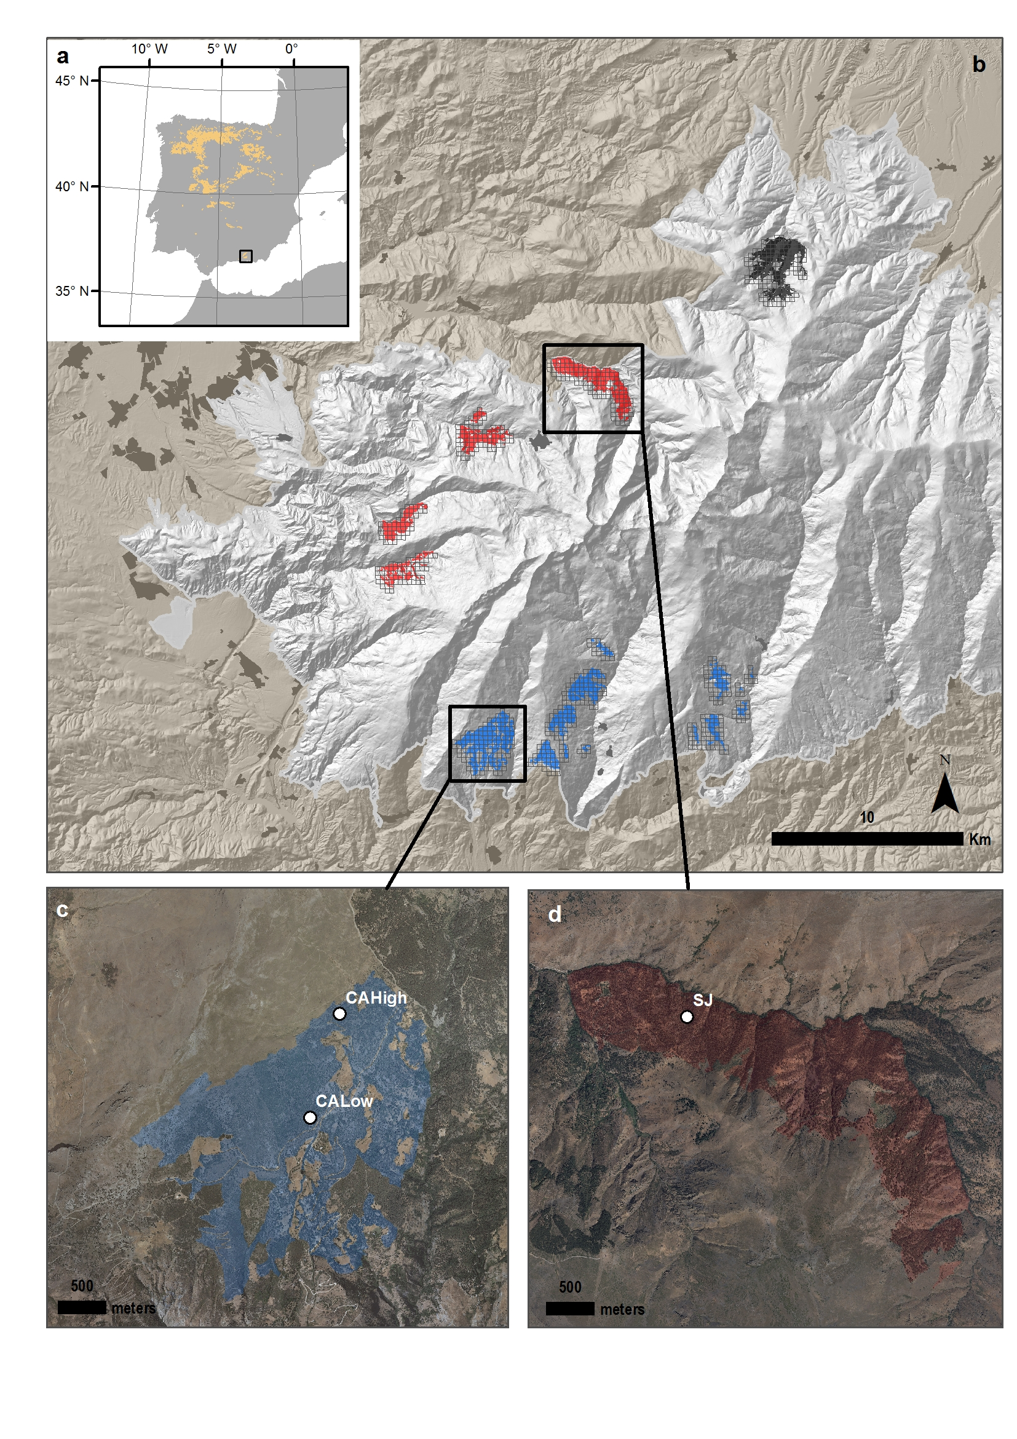

##### 

**Figure 2.** EVI standardized anomaly during the period 2000-2016 for northern and southern populations. Error bars show standard error.

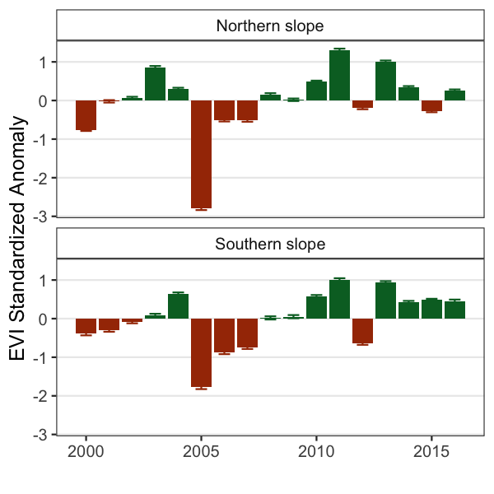

##### 

##### 

**Appendix S4.** Percentage of pixels showing browning, greenning or no-changes during the 2005 and 2012 drought events according to EVI standardized anomalies.

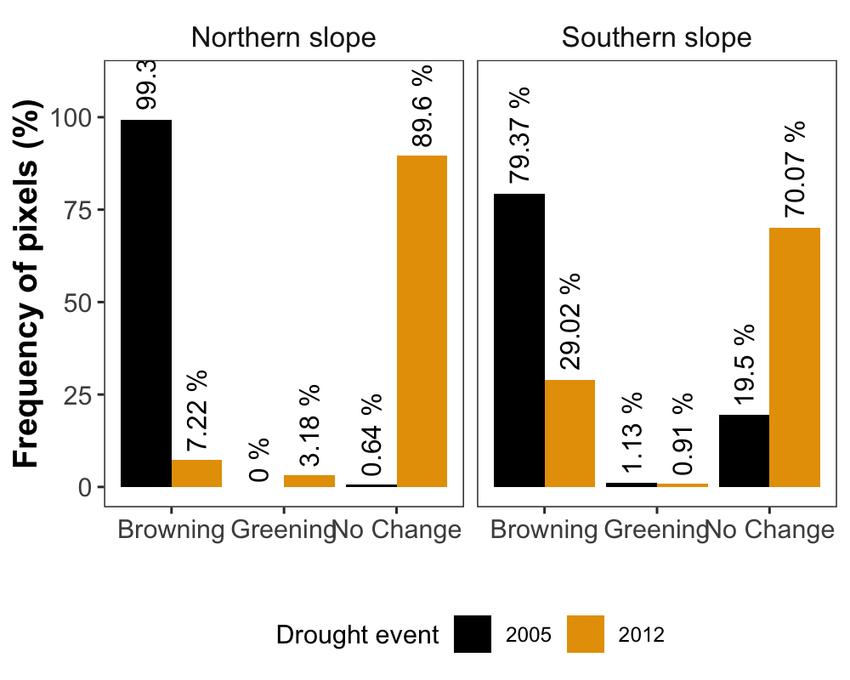

##### 

##### 

**Figure 4.** Basal Area Increment (BAI) chronologies of *Q. pyrenaica* for northern population (SJ; *green*) and southern ones: low-elevation (CA-Low; *pink*) and high-elevation (CA-High, *purple*) sites. Shading areas correspond to standard error of the mean. Number of series are displayed in the upper plot. We only show years replicated with # series > 5. Linear trend since 1975 is shown for southern high-elevation site (CA-High) .AREGLAR ESTO #####

##   
## Call:  
## lm(formula = bai_mean ~ year, data = dfCaH)  
##   
## Residuals:  
## Min 1Q Median 3Q Max   
## -1229.06 -199.39 -23.58 252.73 1025.78   
##   
## Coefficients:  
## Estimate Std. Error t value Pr(>|t|)   
## (Intercept) -42554.042 10750.240 -3.958 0.000301 ***  
## year 22.444 5.387 4.166 0.000161 ***  
## ---  
## Signif. codes: 0 '***' 0.001 '**' 0.01 '*' 0.05 '.' 0.1 ' ' 1  
##   
## Residual standard error: 423.2 on 40 degrees of freedom  
## Multiple R-squared: 0.3026, Adjusted R-squared: 0.2852   
## F-statistic: 17.36 on 1 and 40 DF, p-value: 0.0001607

##   
## Call:  
## lm(formula = bai_mean ~ year, data = dfCaL)  
##   
## Residuals:  
## Min 1Q Median 3Q Max   
## -567.42 -124.86 24.84 128.92 472.78   
##   
## Coefficients:  
## Estimate Std. Error t value Pr(>|t|)   
## (Intercept) -18540.319 5288.062 -3.506 0.001138 **   
## year 9.857 2.650 3.720 0.000612 ***  
## ---  
## Signif. codes: 0 '***' 0.001 '**' 0.01 '*' 0.05 '.' 0.1 ' ' 1  
##   
## Residual standard error: 208.2 on 40 degrees of freedom  
## Multiple R-squared: 0.257, Adjusted R-squared: 0.2384   
## F-statistic: 13.84 on 1 and 40 DF, p-value: 0.0006119

##   
## Call:  
## lm(formula = bai_mean ~ year, data = dfSJ)  
##   
## Residuals:  
## Min 1Q Median 3Q Max   
## -665.57 -261.09 -80.58 300.42 801.70   
##   
## Coefficients:  
## Estimate Std. Error t value Pr(>|t|)   
## (Intercept) -15156.260 9104.477 -1.665 0.104   
## year 8.086 4.562 1.772 0.084 .  
## ---  
## Signif. codes: 0 '***' 0.001 '**' 0.01 '*' 0.05 '.' 0.1 ' ' 1  
##   
## Residual standard error: 358.4 on 40 degrees of freedom  
## Multiple R-squared: 0.07281, Adjusted R-squared: 0.04963   
## F-statistic: 3.141 on 1 and 40 DF, p-value: 0.08395

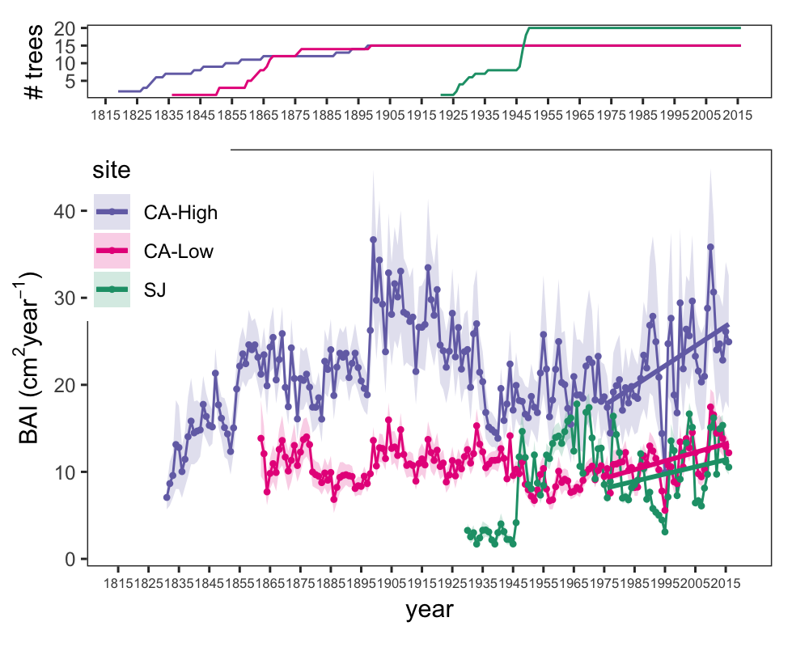 #####

**Figure 7.** Comparison of median growth change ($GC$) following Nowacki and Abrams (1997) for *Q. pyrenaica* sites. Dashed black lines indicate a threshold of 50 % of GC (see material and methods). Note that y-axes do not correspond in all of the three panels for the sake of clarity.

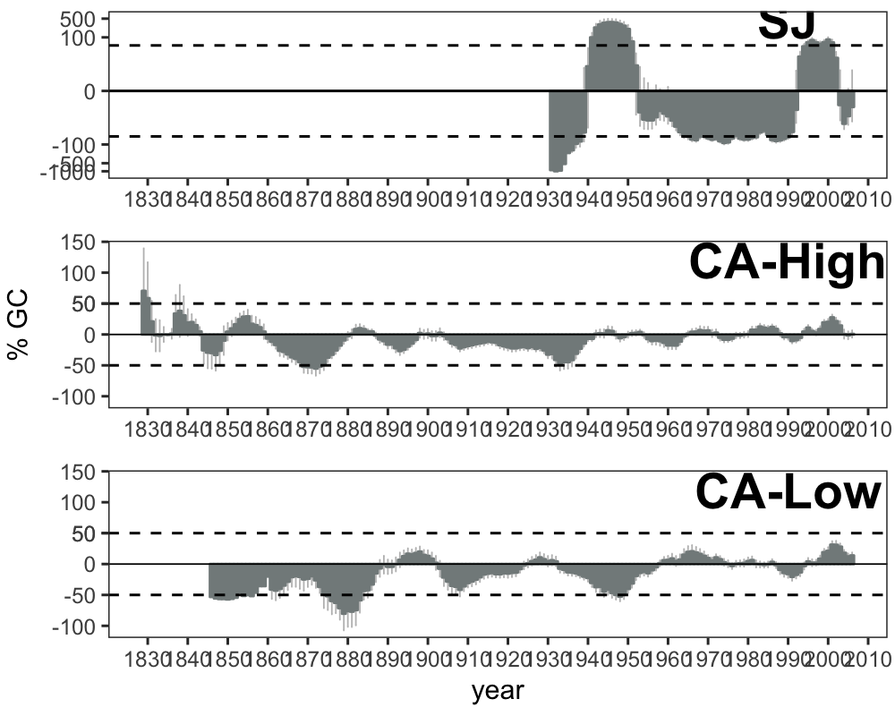

##### 

##### 

**Appendix S5.** Resilience metrics of the tree-growth for the most severe drought events (as from Appendix S3). *Left*: Resistance (*Rt*); *Center*: Recovery (*Rc*); *Right* Resilience (*Rs*). Points indicate average of resilience metrics for all populations. Error bar corresponds standard error. Resilience metrics were computed for each population (sample depth > 10) and drought event.

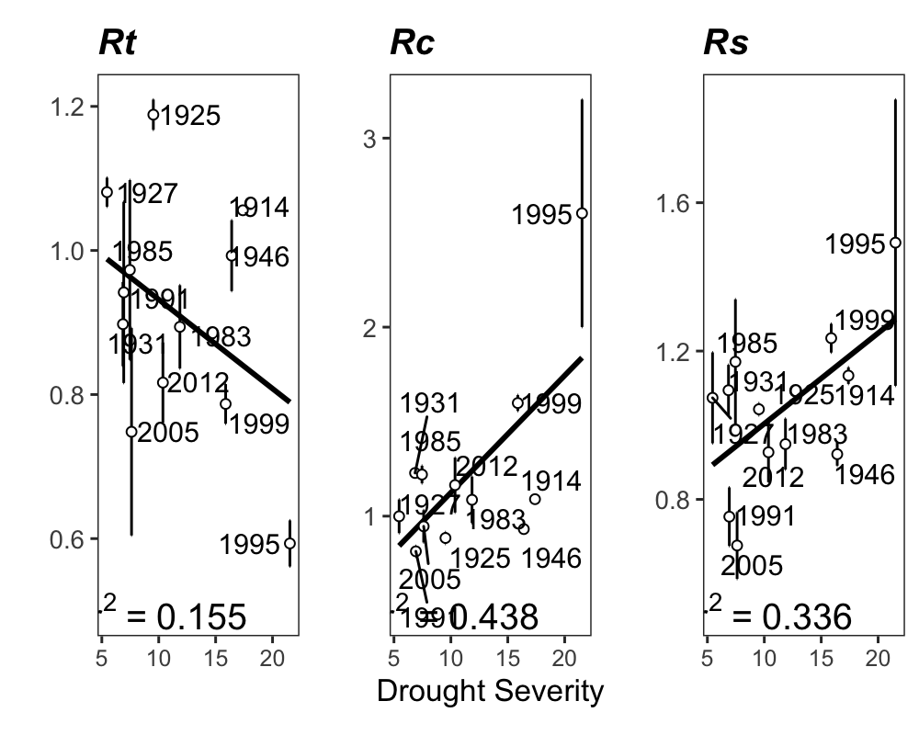

##### 

##### 

**Figure 3.** Response *Q. pyrenaica* forests to drought in terms of resistance, recovery and resilience of greenness (EVI; left-plots) and tree radial growth (BAI; right-plots) for the years 2005 and 2012. For EVI we compared northern populations (*black fill circle*) with southern ones (*blue empty circle*). For BAI we compared northern population (San Juan, SJ; *black triangle*) with southerns populations: Cáñar-High (CA-High; *blue empty squares*) and Cáñar-Low (CA-Low; *blue fill squares*). Different letters above error bars indicate significant *post hoc* differences between groups (see material and methods).

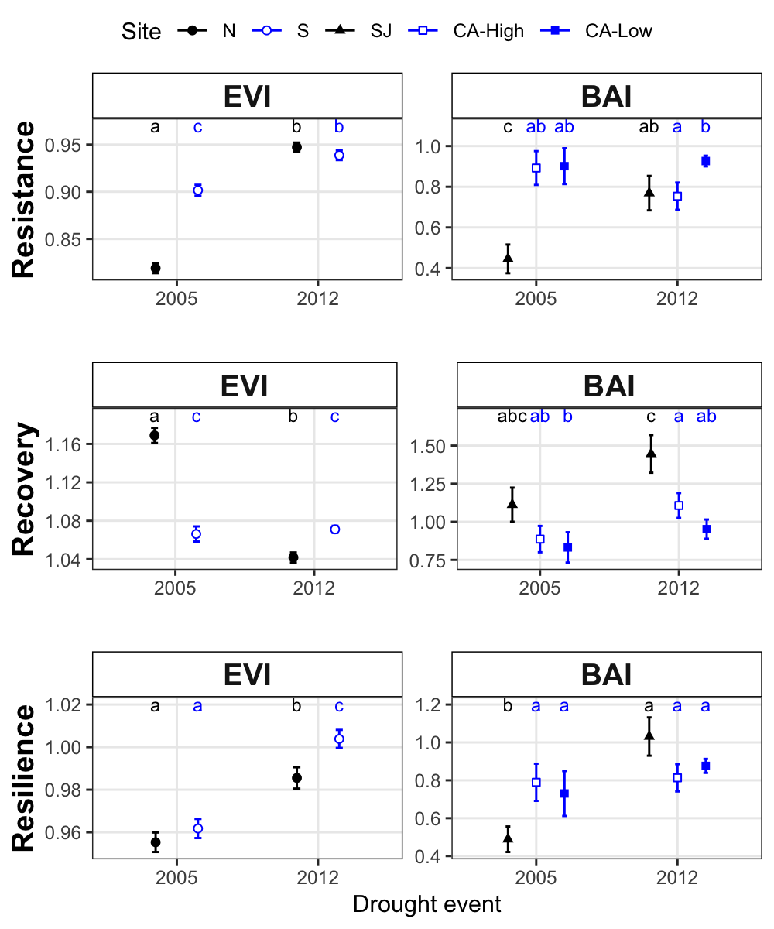

##### 

##### 

**Figure 6.** Correlation coefficients obtained by relating tree-ring residual chronologies (RWI) of *Q. pyrenaica* and monthly climatic data: precipitation and 6-month SPEI (a), minimun (b) and maximun (c) temperatures. *green* bars: northern site (SJ); *light blue* bars: low-elevation southern site (CA-Low); and *dark blue* bars: high-elevation shouthern site (CA-High). Asteriks indicate significant ($P<0.05$) correlation coefficients.

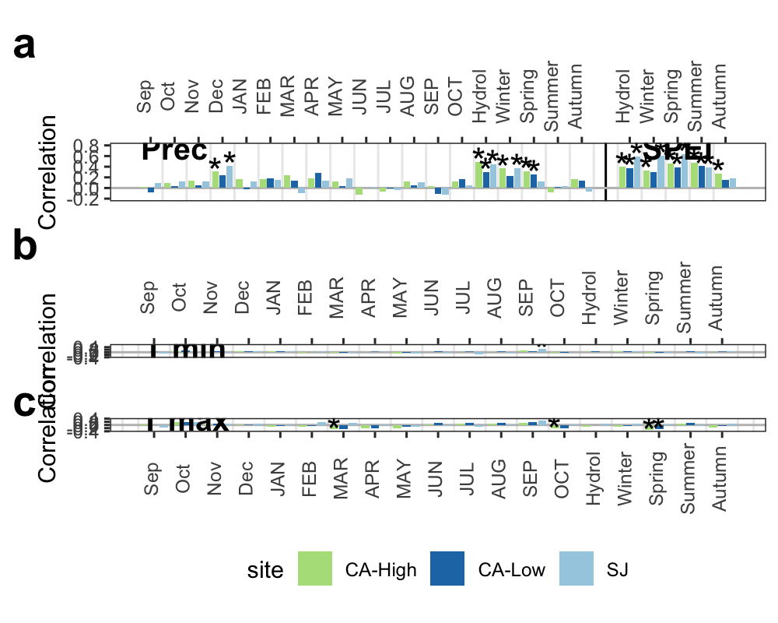

##### 

##### 

**Figure 8**. Percentage of *Q. pyrenaica* trees affected by GC > 50 % by site. *Black* line shows number of trees (rigth-axis). Data for number of trees > 2 is shown.

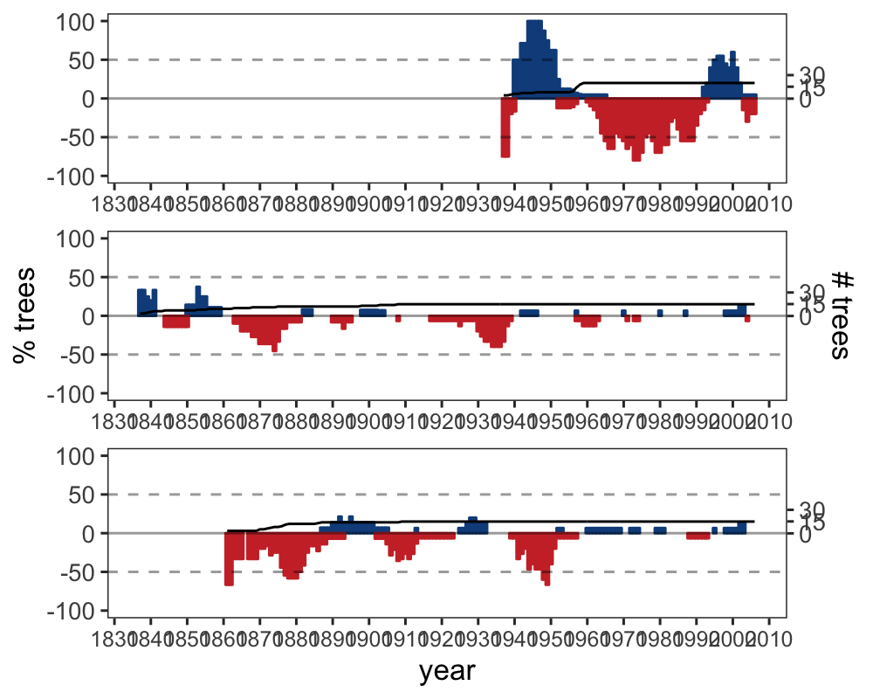

##### 

##### 

**Appendix S1.** Temporal evolution of cumulative precipitation (hydrological year) during the period 1950-2017. Points represent mean and errorbars standard error. *Black* line indicates mean for all period. *Red* lines represent -1 and -2 standard deviation (*dotted* and *dashed* lines respectively). *Blue* lines represent +1 and +2 standard deviation (*dotted* and *dashed* lines respectively). Years with average values below -1SD are labelled. Data from 28 meteorological stations distributed around Sierra Nevada area (from National Spanish Meteorological Services, AEMET). ***Inset plot***: cumulative precipitation during the hydrological years 2004-2005 (*blue line*) and 2011-2012 (*red line*). The boxplot representing the average from 1950-2015 period. Data from meteorological station Granada, Base Aérea.

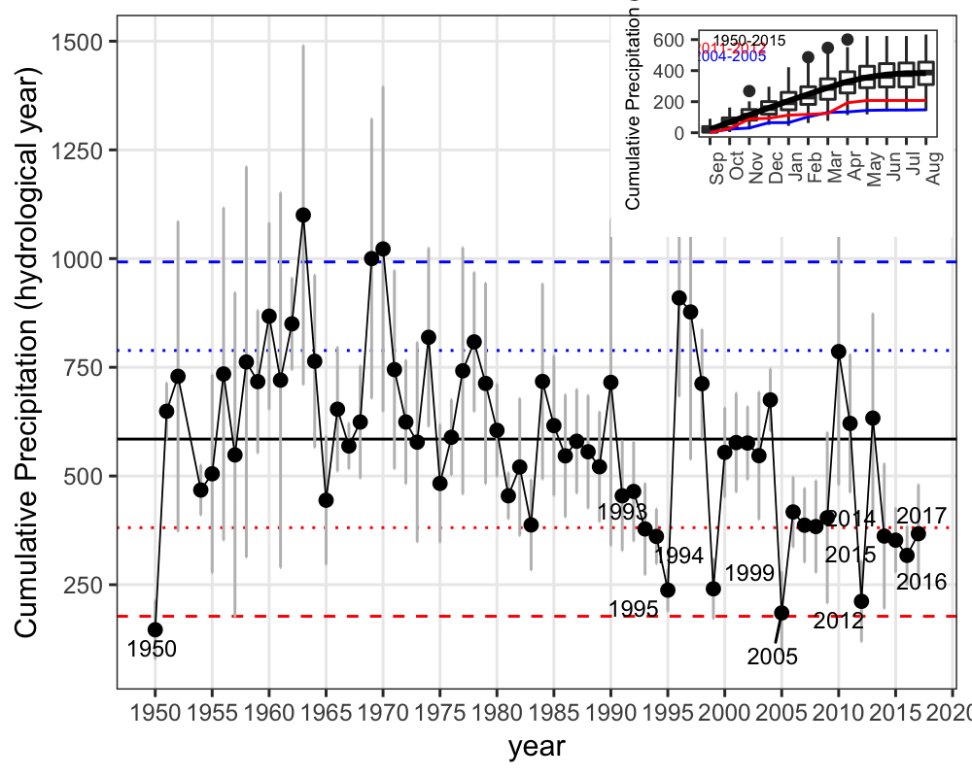

##### 

##### 

**Appendix S2**. Drought severity in the Sierra Nevada for the 1950-2016 period based on the Standardised Precipitation-Evapotranspiration Index (SPEI). Data from Global SPEI database (<http://spei.csic.es/database.html>). We obtanied the SPEI data for a 12 month scale and for all 0.5º grid cells covering Sierra Nevada.

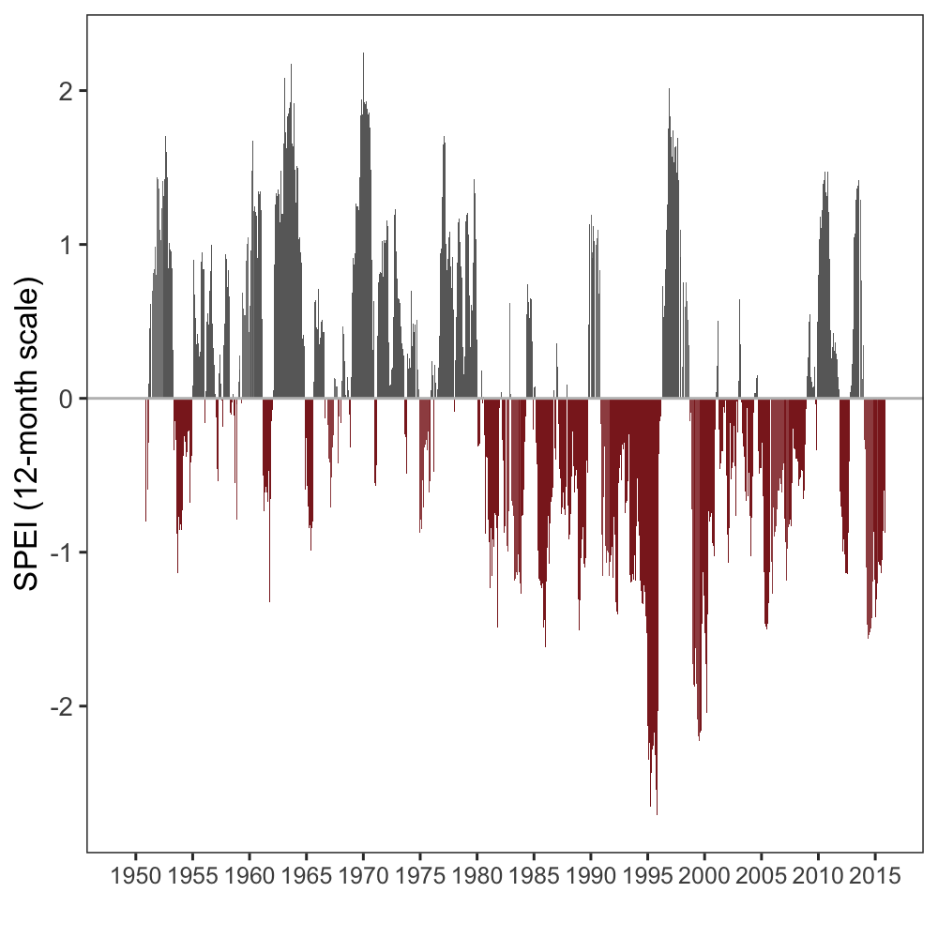

##### 

##### 

##### 

**Figure 8**. Percentage of *Q. pyrenaica* trees affected by GC > 50 % by site. *Black* line shows number of trees (rigth-axis). Data for number of trees > 2 is shown.



##### 

##### 

**Figure 5.** Residual tree-ring chronologies obtained for the *Q. pyrenaica* sites. Dashed red lines indicate the start of the reliable period (EPS > 0.85). Dotted black lines showing the severe drought years identified in our climatic data (see Table S3).

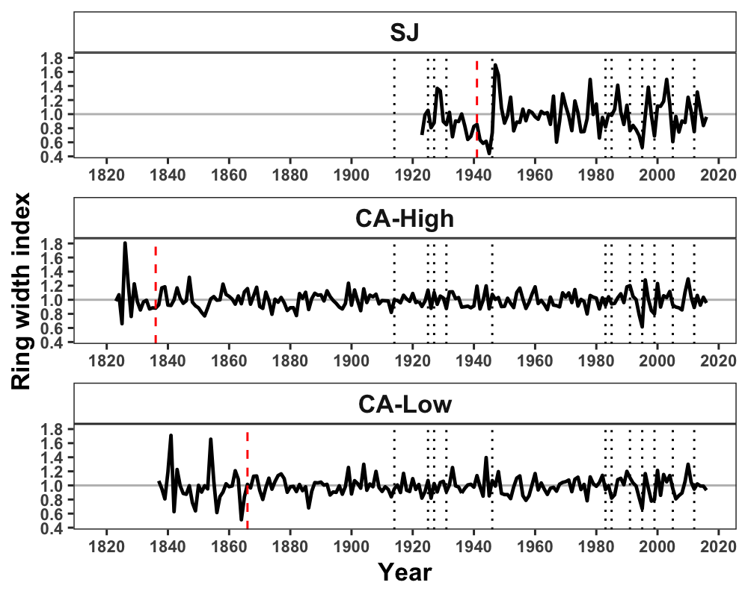

##### 

##### 

**Appendix S1.** Temporal evolution of cumulative precipitation (hydrological year) during the period 1950-2017. Points represent mean and errorbars standard error. *Black* line indicates mean for all period. *Red* lines represent -1 and -2 standard deviation (*dotted* and *dashed* lines respectively). *Blue* lines represent +1 and +2 standard deviation (*dotted* and *dashed* lines respectively). Years with average values below -1SD are labelled. Data from 28 meteorological stations distributed around Sierra Nevada area (from National Spanish Meteorological Services, AEMET). ***Inset plot***: cumulative precipitation during the hydrological years 2004-2005 (*blue line*) and 2011-2012 (*red line*). The boxplot representing the average from 1950-2015 period. Data from meteorological station Granada, Base Aérea.

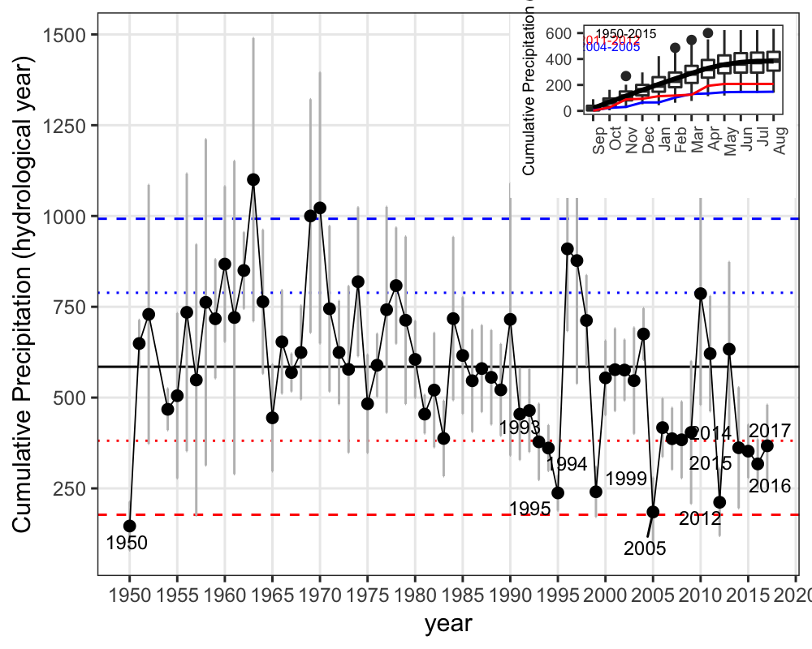

IECA, I. de E. y C. de A. 2009. Digital colour orthophotograph of andalusia 2008-2009. Sevilla. Regional Government of Andalusia.

Nowacki, G. J., and M. D. Abrams. 1997. Radial-growth averaging criteria for reconstructing disturbance histories from presettlement-origing oaks. Ecological Monographs 67:225–249.

Pérez-Luque, A. J., R. Zamora, F. J. Bonet, and R. Pérez-Pérez. 2015. Dataset of migrame project (global change, altitudinal range shift and colonization of degraded habitats in mediterranean mountains). PhytoKeys 56:61–81.